**2.1 Browser Plugins**

**Overview**

Throughout your penetration testing endeavors, you will encounter a collection of plugins that you may install in your browser that are going to make your life easier. This can be from identifying technologies installed in a page,to modifying and exporting cookies to import into another program such as curl .

**Supported Browser**

Kali ships with Firefox so I'll be focusing on that.

**FoxyProxy**

FoxyProxy allows you to rapidly switch between proxies for traffic directed to the browser. This is perhaps the plugin you will use the most. This plugin will allow you to quickly send the traffic for your current session to the tool BurpSuite . If you are not familiar with BurpSuite , it is essentially the standard in evaluating web-based applications for security. The tool is a penetration testing staple and you will use it constantly when testing Webapps.

You can read more about it, and complete free training with PortSwigger at https://portswigger.net/web security

**Installing and configuring FoxyProxy**

First thing first, from within Firefox on Kali , head to the menu, and select Add ons

And search for it:

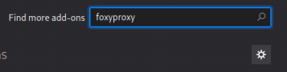

Next, you can select it and click on Add to Firefox

You will see one more pop-up to accept to install it, this is covering the permissions the addon requires. 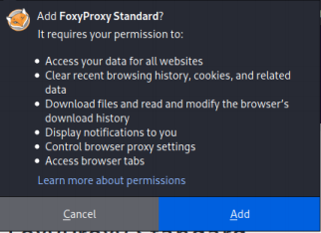

**Starting BurpSuite and getting the proxy address**

From the Kali menu, open up BurpSuite just accept the default for the project Once you are at the main screen, select Proxy > Options and you will see the proxy listener as below. Note this down as you will need it. Mine is 127.0.0.1:8080

Keep the proxy page open in the background as we will need it again later.

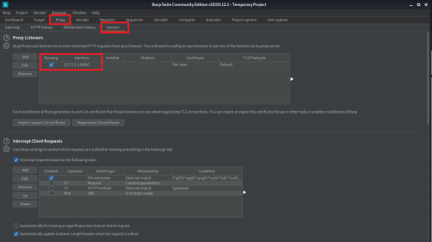**Back to the browser**

Back in Firefox , click on the FoxyProxy addon and then Options . This will bring up the addon configuration screen. From there, click on Add .

Enter the proxy listener address we collected from BurpSuite and give it a meaningful name: 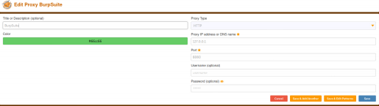After that, hit Save

**Adding the BurpSuite CA**

Almost there, we need to add the BurpSuite Certificate Authority . This will stop us getting browser errors when proxying pages.

Browse to the IP address of the proxy as per below

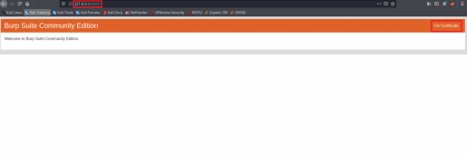

Click on CA Certificate on the right, and then save the file somewhere you will remember: 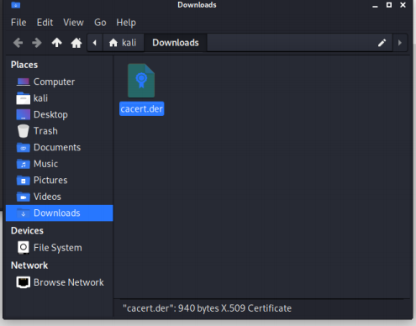

Next, back in Firefox , bring up the Settings (or whichever it might be named on your display)menu and then to go Privacy & Security and scroll all the way to the bottom. Once there, click on View Certificates

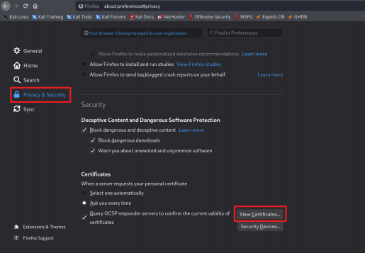Now click on Import

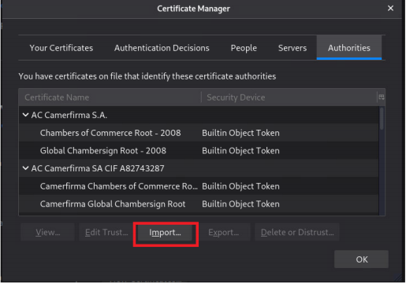

In the new window, select the downloaded certificate and click on Open

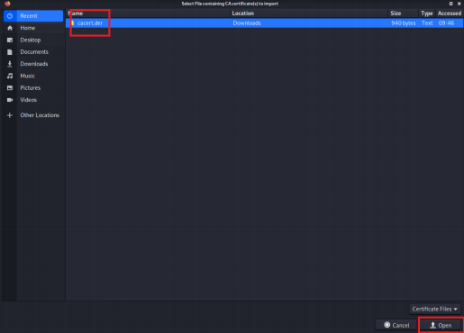On the new page, select Trust this CA to identify websites and then OK 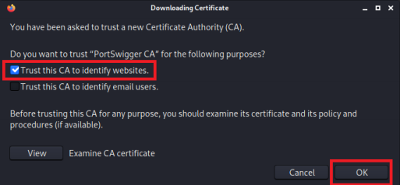After that, you can just exit out of the settings page.

**Using the Proxy**

Now the proxy is installed, it is time to test it. Click the addon in the top right, and select BurpSuite . If in the future you want to turn it off, just select Turn Off (Use Firefox Settings) .

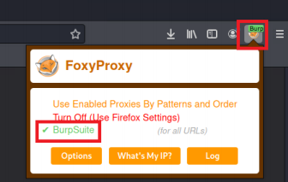

If you try to browse to a page while the proxy is turned on, BurpSuite will appear and show you the intercepted query.

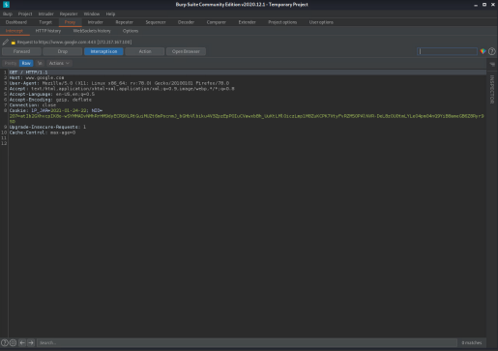

**Cookie-Editor**

This plugin will let you create, edit, and modify cookies for an existing session. Add it to firefox in the same manner as the FoxyProxy addon.

Once installed, you may click on it to view the cookies for the current browser tab. 

**Wappalyer**

This addon will show you the technologies installed on specific websites. Very helpful as it can show you if they are running an old, vulnerable version, or other technologies (such as flask) that are extremely vulnerable when incorrectly configured.



Once it is added to Firefox, just click on the addon to see the technologies on a page 

**Tamper-Monkey**

Tampermonkey is a more advanced tool. This addon will let you run user-scripts on the page. For example, you can insert a javascript that manipulates the way the page is run

**Auth-helper**

This addon allows you to generate OTP codes directly from the browser. For example, say you compromised an OTP secret, you could add the OTP to your browser, and generate codes as if having access to the genuine device.

